*Data preparation*

*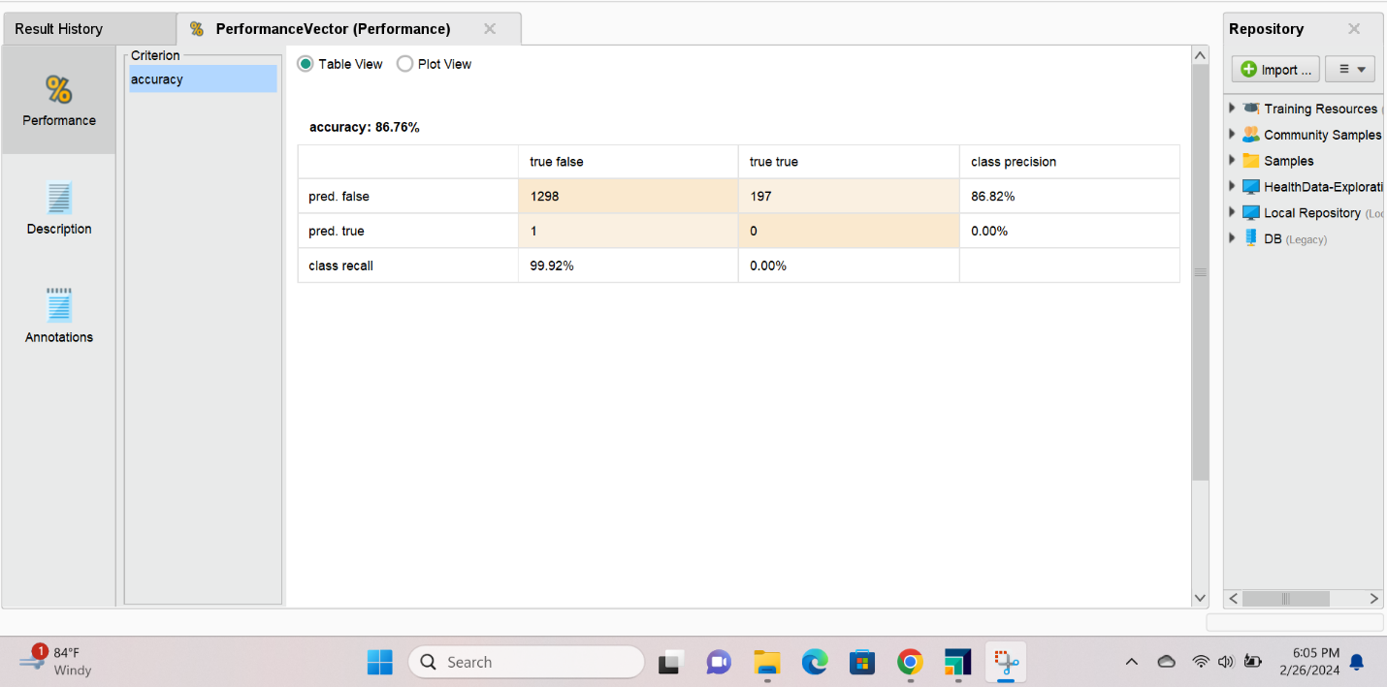*

*Neural Network Model*

*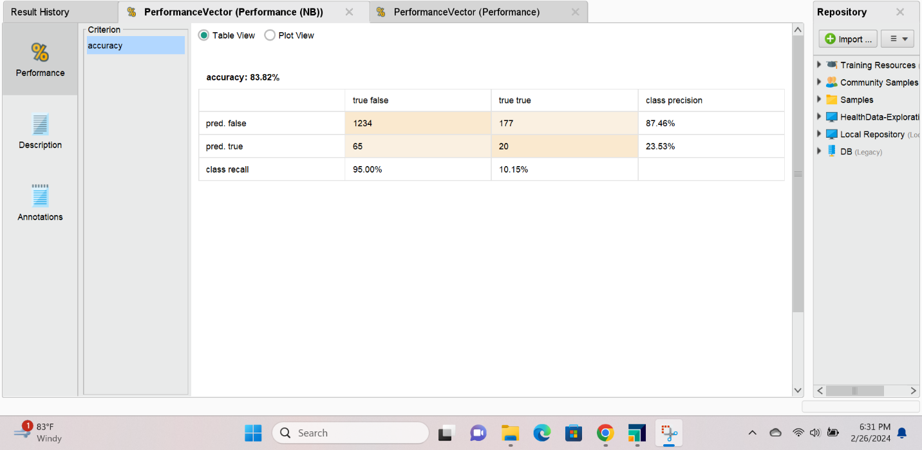*

*Naïve Bayes Model*